PICTURES OF GENOVATE LAUNCH AT ANKARA UNIVERSITY
22th May 2013, Rectorate 100.th Anniversary Hall,

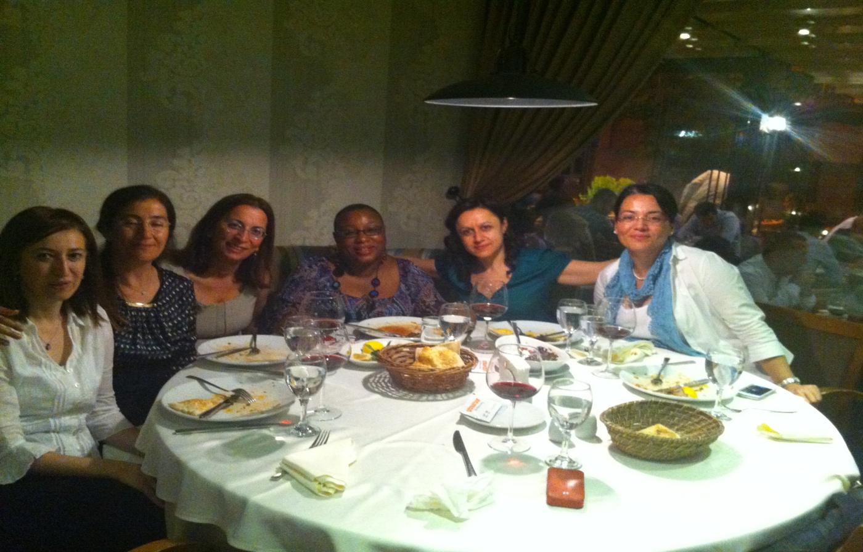
Dinner at Gunaydın Restaurant Before Genovate Launching- 21th May 2013, Ankara- Turkey.
Ruken Ozturk, Guzin Yamaner, Bedriye Poyraz, Uduak Archibong, Çiler Dursun, Sema Becerikli.
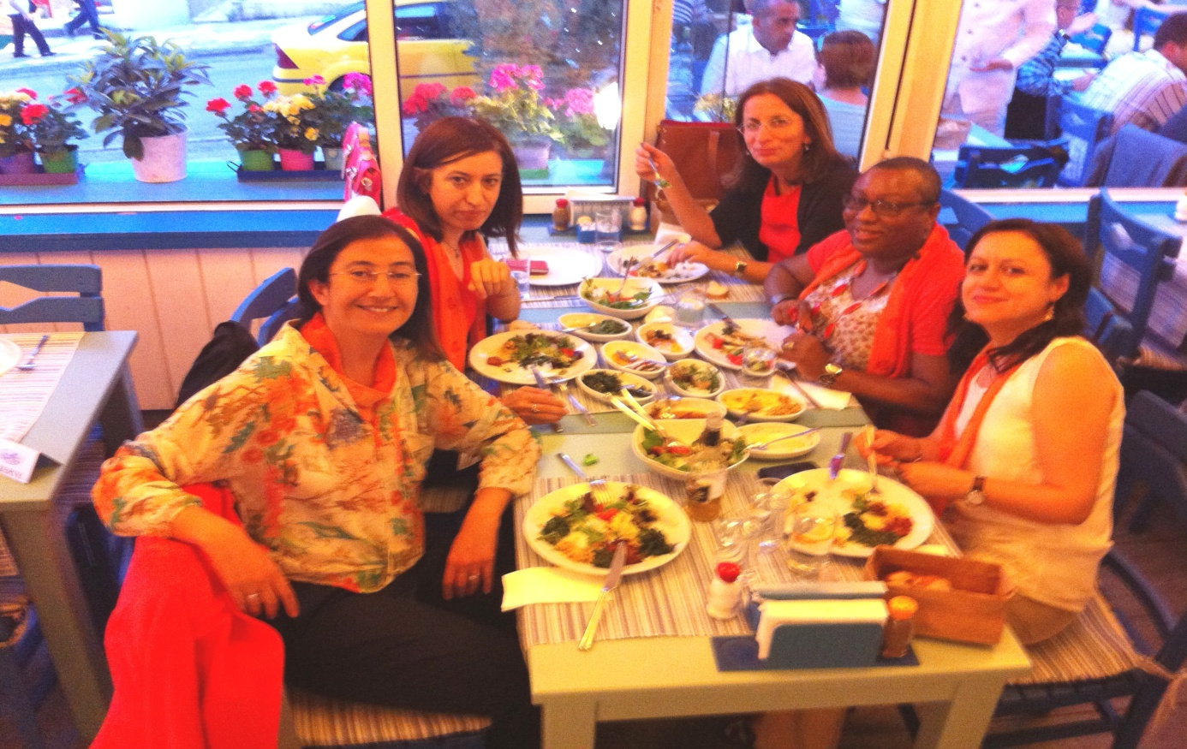
Dinner in a Fish Restaurant after Genovate Launching- 22th May 2013- Ankara
Guzin Yamaner, Ruken Öztürk, Bedriye Poyraz, Uduak Archibong, Çiler Dursun

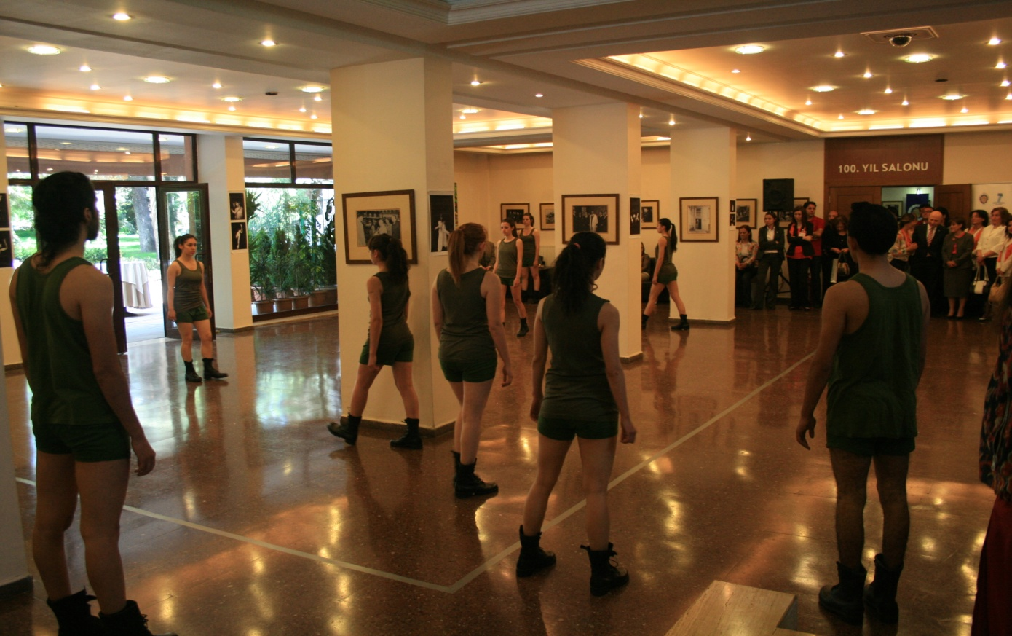
Modern Dance Show of Conservatory Students at the Start of Genovate Launch of AU- 22th May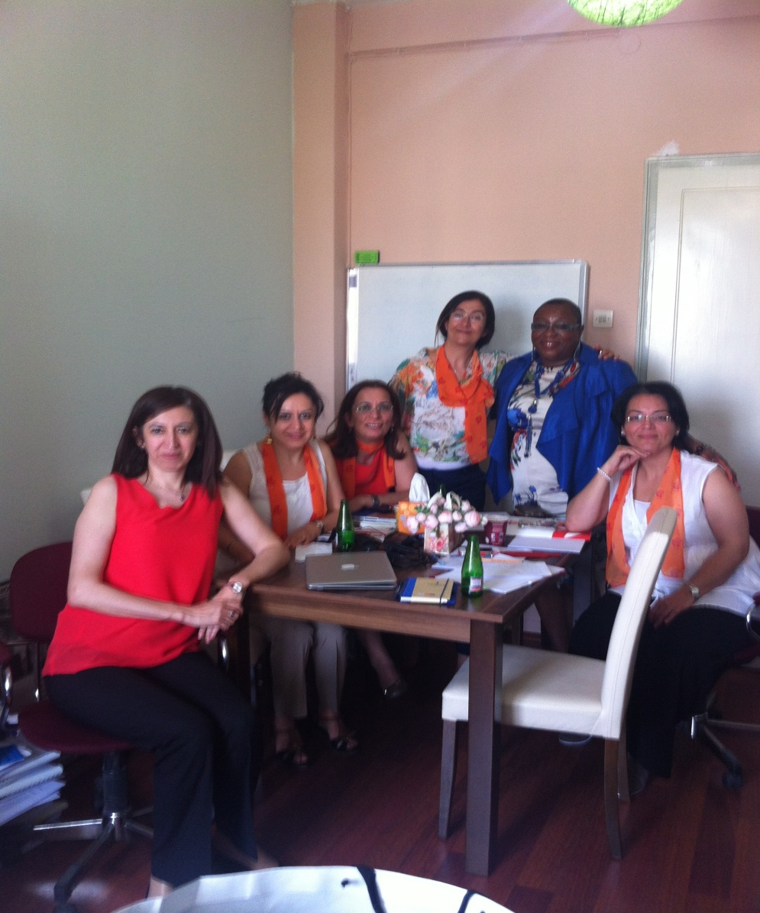
After Launching Meeting at the Office of Çiler Dursun- 22th May 2013

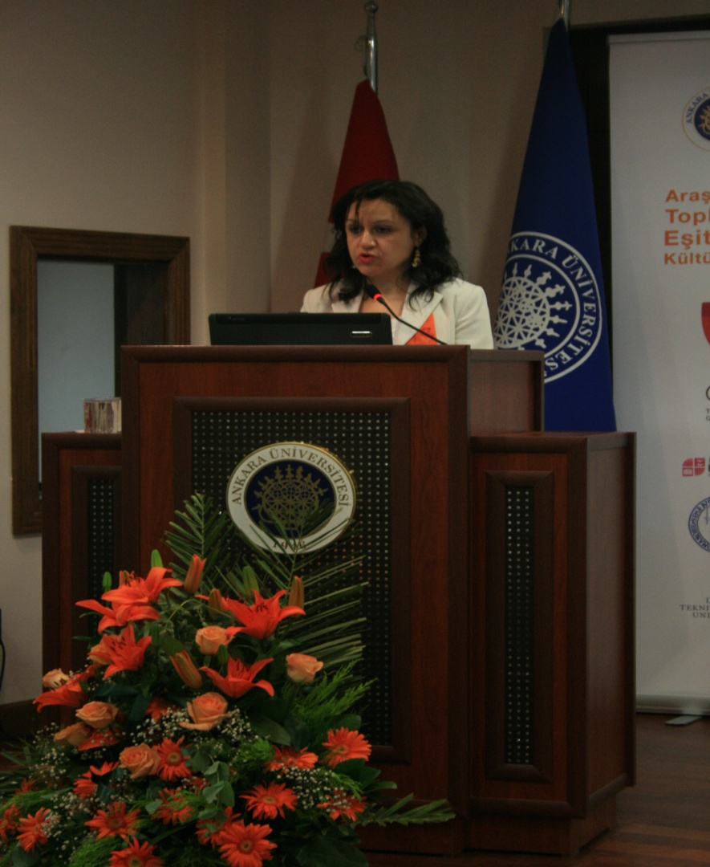
Opening Speech of Çiler Dursun at Genovate Launch of AU- 22th May 2013- Ankara- Turkey
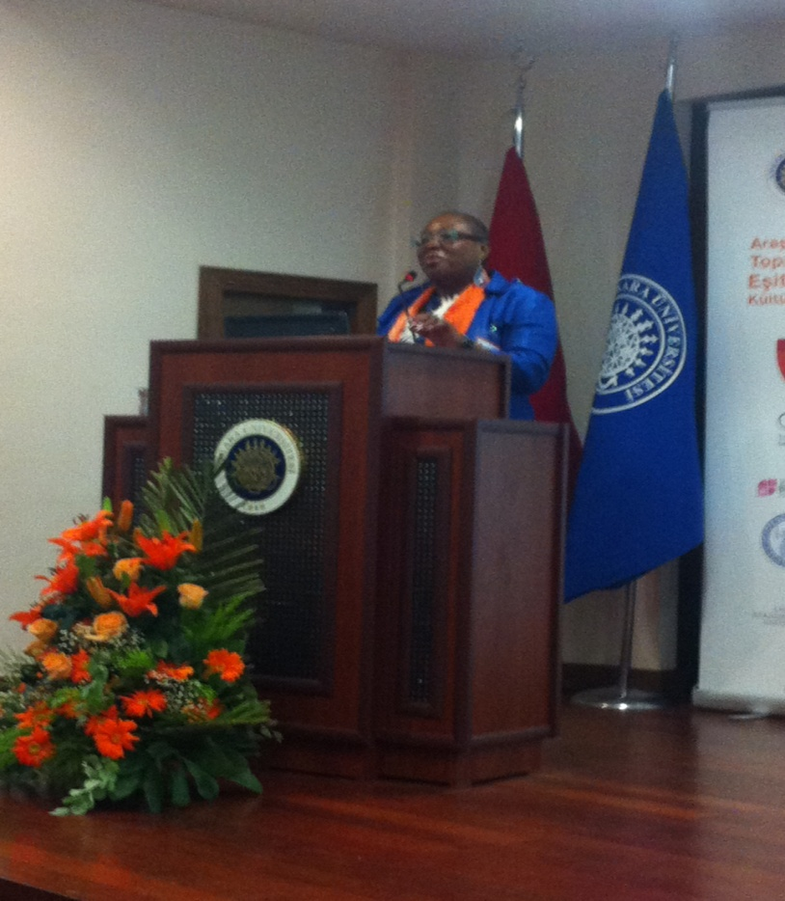
Speech of Uduak Archibong at Genovate Launch of AU- 22th May 2013- Ankara- Turkey
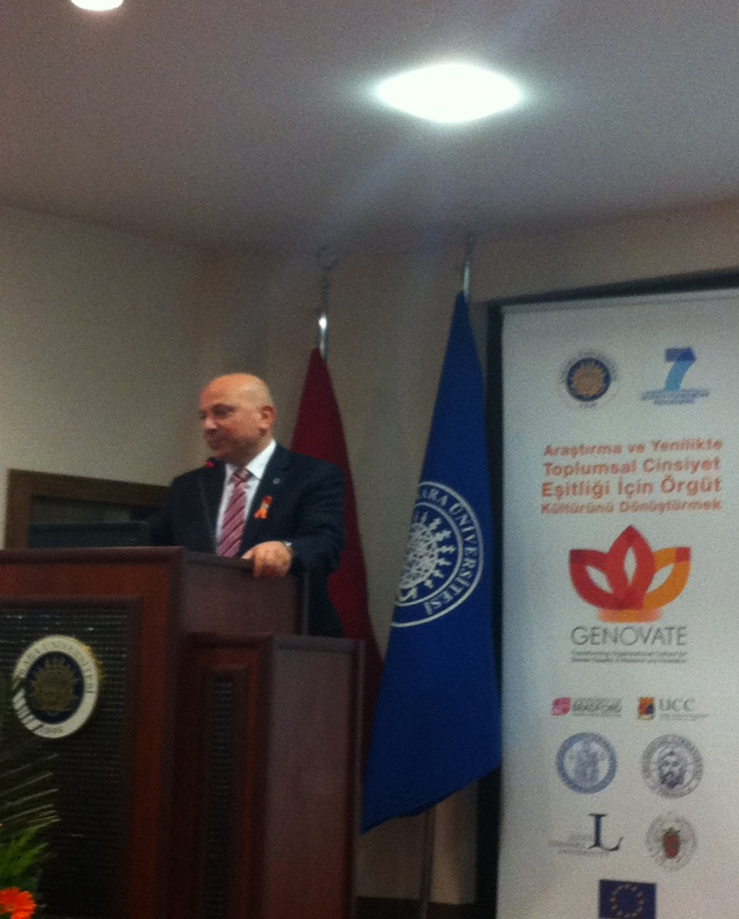
Speech of Rector Erkan İbiş, Genovate Launch of AU- 22th May 2013- Ankara- Turkey.

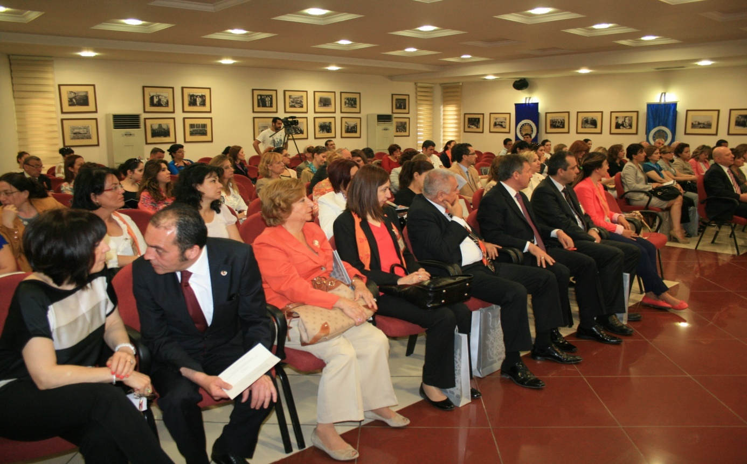
Guests for Genovate Meeting at 100th Yıl Hall

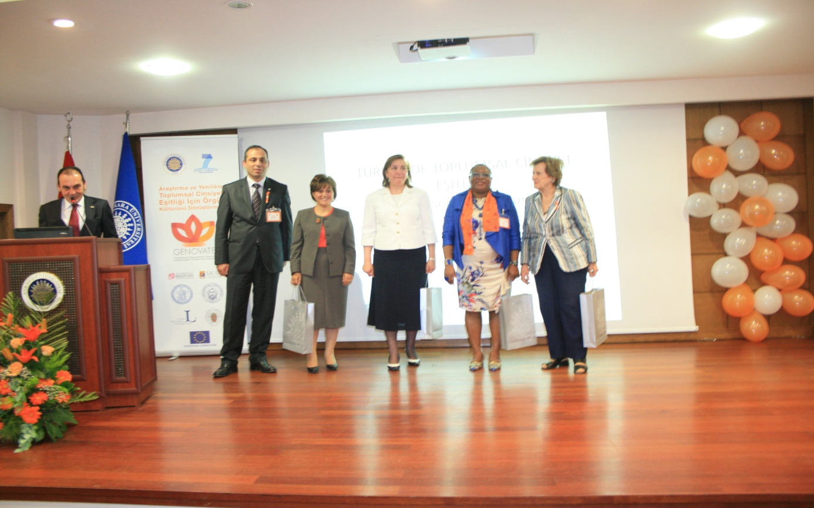
Vice Rector, Deputy Ministry of Family and Social Policies Ministry, Head of the Gender Equality Comisson of Turkish Parliamentary, Genovate Manager and Coordinator, The First Women Academician of AU in polisitcal science. (Genovate Launch of AU- 22th May 2013)

Genovate Project Launch was held in the Ankara University with the participation of high profile politicians, managers of AU, academicians and students as well. At the beginning of launching Modern Dance Show was offered by th eConservatory Students of Ankara University.
Scientific Coordinator of AU , Prof.Dr.Çiler Dursun made a speech on the importance of Genovate in AU. General coordinator of Genovate Prof.Dr. Uduak Archibong, Rector Prof.Dr. Erkan İbiş has followed by their speeches. Deputy Minister of Family and Social Policies Mnisitry Assoc.Prof.Aşkın Asan has a very intersting speech on the gender discrimination issues in Turkey. The Head of the Gender Equality Commission in Turkish Parliamentary, Azize Sibel Gönül has a supportive contribution with her speech. Lastly, Prof.Dr. Serpil Sancar and first women academician of AU Nermin Abadan made their speeches. After all these speeches, a reception is offered and ceremony was finished with a great success.

